Project idea: Electricity Usage-Based CO2 Emission Monitoring Backend.

Description: A backend system that ingests electricity usage telemetry, validates and normalizes the data, calculates CO₂ emissions using standardized grid emission factors, stores results reliably, and supports historical queries and audit-ready reporting.
The system is designed to mirror how real-world organizations track electricity consumption and translate it into carbon emissions for environmental analysis, compliance, and sustainability reporting.

Why this project?
- Climate change is one of the most urgent global challenges, and electricity generation is a major source of greenhouse gas emissions.
- Many organizations already collect electricity usage data, but converting that data into accurate, standardized CO₂ emission figures is often manual, fragmented, or error-prone.
- By building this system, I gain hands-on experience in backend and data engineering while working on a problem that has real environmental and industrial relevance.

This system solves the problem of:
Reliably transforming raw electricity usage data into accurate, traceable CO₂ emission calculations and connecting companies with the tech sources.
More specifically, it:
- Eliminates manual emission calculations
- Enforces data validation and unit consistency
- Applies standardized emission factors correctly
- Produces audit-friendly, reproducible results
- Enables historical analysis of emissions over time

What’s special about my project that helps it stand out:

My project acts as an intermediary connecting business owners/investors with those who create the technologies. Like Amazon, but with clear, calculated data for companies.

Where I plan to get my dataset from:
- Real electricity usage datasets from energy audits conducted by my father
- Simulated electricity consumption time-series
- Public electricity and grid emission factor datasets (for reference and validation)

What my system does:
- Ingest time-series electricity usage data (kWh)
- Validate timestamps, values, regions, and units
- Normalize all data to standard units (kWh)
- Apply grid-based emission factors to calculate CO₂ emissions
- Persist raw usage data and calculated emissions reliably
- Support historical queries and summaries
- Generate audit-friendly, deterministic records
- Log all operations for traceability and debugging

Example data for my system:

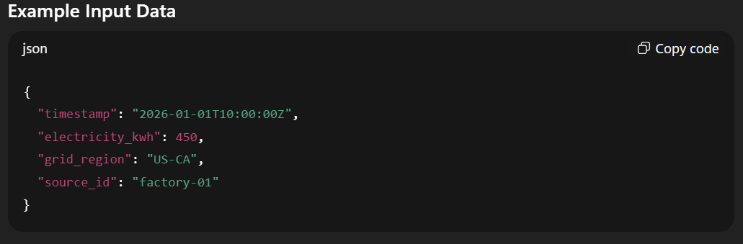
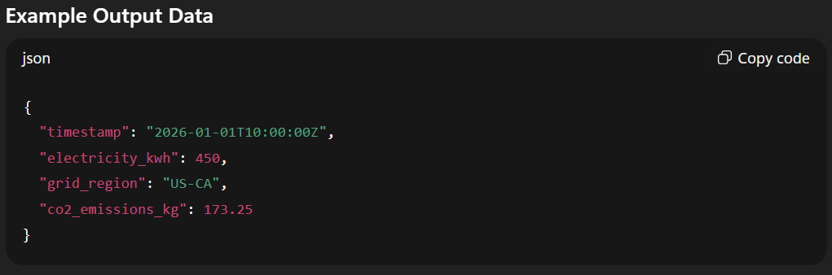

Tech Stack:
- Language: Python
- Framework: FastAPI
- Database: SQLite (start) -> PostgreSQL
- Validation: Pydantic
- Testing: pytest
- Environment: Linux + Git

Project Phases

Phase 1 — Data Ingestion & Validation (Foundation)
Goal: Accept electricity usage data safely and correctly.
- REST API endpoint to ingest electricity usage records
- Schema validation (timestamps, regions, kWh values)
- Range checks (non-negative, realistic consumption values)
- Unit normalization (all values → kWh)
- Duplicate detection and idempotent writes
- Structured logging for every request
Outcome: Only clean, trustworthy data enters the system.

Phase 2 — Persistent Storage (Reliability)
Goal: Preserve historical electricity and emission data.
- Store validated usage data and calculated emissions
- Index by time, source, and region
- Ensure consistent, repeatable calculations
- Support growing time-series datasets
Outcome: Data is reliable, queryable, and audit-ready.

Phase 3 — Emission Calculation Engine (Core Intelligence)
Goal: Accurately compute CO₂ emissions.
- Maintain standardized grid emission factor tables
- Apply deterministic calculation logic
- Store calculated emissions as first-class records
- Ensure results are reproducible for audits
Outcome: The system produces correct, explainable emission numbers.

Phase 4 — Query & Reporting APIs (Usability)
Goal: Enable analysis and reporting workflows.
- Query electricity usage and emissions by time range
- Generate daily / weekly / monthly summaries
- Filter by source or region
- Provide metadata discovery endpoints
Outcome: Users can extract insights without touching raw data.

Phase 5 — Reliability, Testing & Auditability (Production Mindset)
Goal: Make the system trustworthy and maintainable.
- Unit and integration tests
- Clear error handling and status codes
- Versioned APIs
- Comprehensive README and API documentation
- Consistent logging for debugging and audits
Outcome: The system behaves like real industry software.
.

Mental framing (V1)
“I’m building a backend system that ingests electricity usage and converts it to standardized, audit-ready CO2 emission calculations.”

My plan:
VERSION 1: Tính toán lượng CO2 thải ra từ lượng điện và năng lượng tiêu thụ
VERSION 2: Xuất ra dạng biểu đồ và những thông tin đó ở database
VERSION 3: Thêm nhiều nguồn thải CO2 khác.
VERSION 4: Từ những dữ liệu đó, đề xuất và kết nối những nhà đầu tư, chủ doanh nghiệp đến những nguồn công nghệ có thể dùng để giải quyết vấn đề. Hệ thống đóng vai trò làm trung gian như Amazon nhưng về tiêu thụ năng lượng.

DATA FOR INGESTION:

I. Activity Data (Primary Input):

1/ Electricity usage:
- Energy Consumption:
- kWh
- (can consider real-time for future upgrades)
- Timestamps:
- Date
- Time
- Timezone
- Location:
- Country
- States
- Grid Region
- Utility Provider

II. Emission Factor Data (Multiplier):

Grid emission data:
- Emission factor (kg CO₂ per kWh):
- CO₂ Emission = Electricity (kWh) * Emission factor per region (kg CO₂ per kWh)

III. Calculation (Output):
- Store:
- calculated_co2_kg
- calculation_year
- method = location-based

MVP:
Estimated CO₂ = kWh × avg regional emission factor

